Key Considerations for Primary Content in Documents
- Download the primary document and open in Word software. This is to validate that if document can be opened without any alerts then document content is correct.

- When naming the primary content document, make sure, It doesn’t include any special characters. The Jobs will fail in such cases.
Examples: @ ® * ! ? & % $ # * : ~ ¨°^ ’ < > ( ) | / \
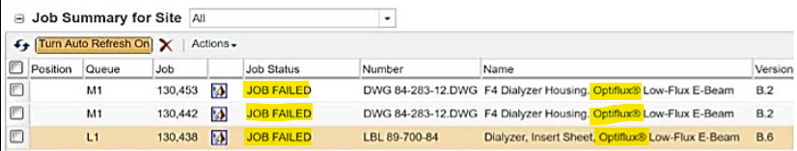

- Use of “Activated” Check Boxes will NOT be supported by GPDM Windchill publishing engine and thus no pdf representation can be created.
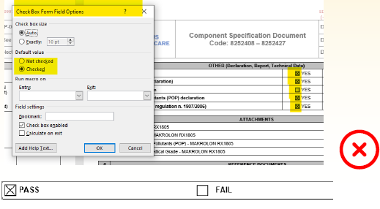
Use check boxes based on the Microsoft Word Developer Function or no check boxes
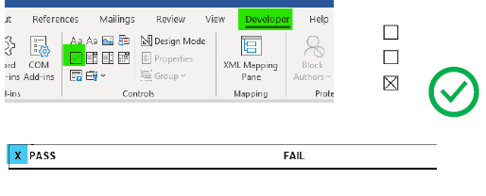

- Before inserting the image into primary content document, check the image extension. Only PNG format is allowed.

- Do not use track changes functionality when creating the primary content document.
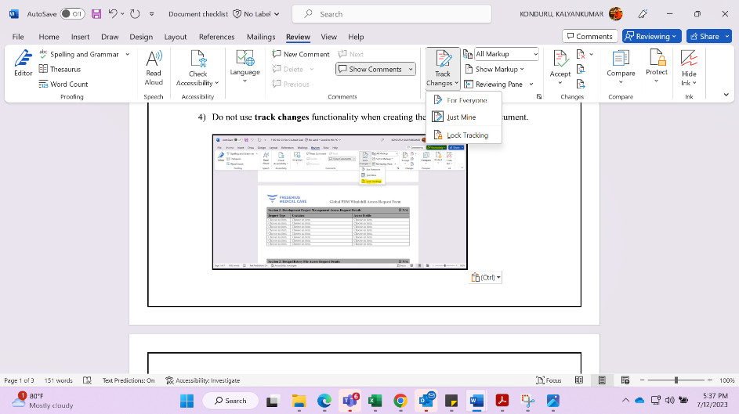

- Make sure no invalid characters are present in the Revision history comment section.
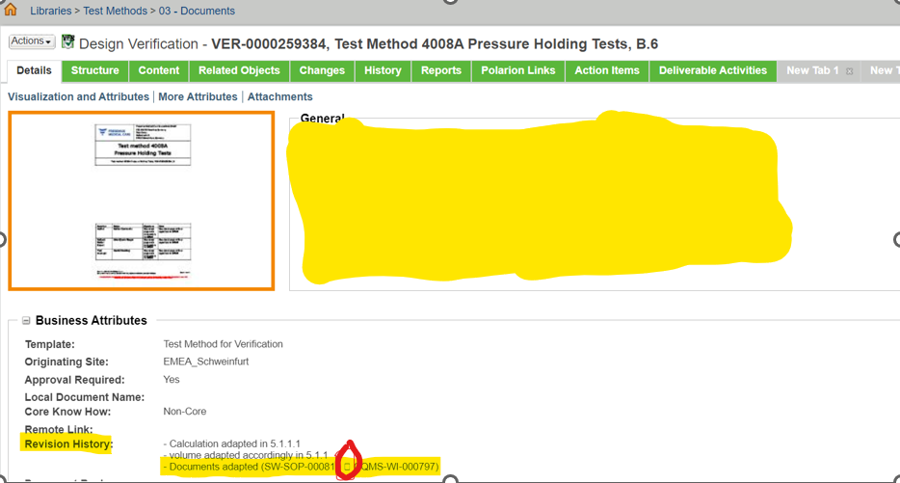
- Revision history comment length issue

- Verify the primary content document correctly before initiating the document approval task.

- Do not upload Documents with incorrect pages sizes as this will cause issues with the watermarking.

- Very large documents may not be able to convert in time. Try and keep file size low.

- Check the primary content document for password protection in document properties. If it has password security, please disable it. Don’t upload password protected document.
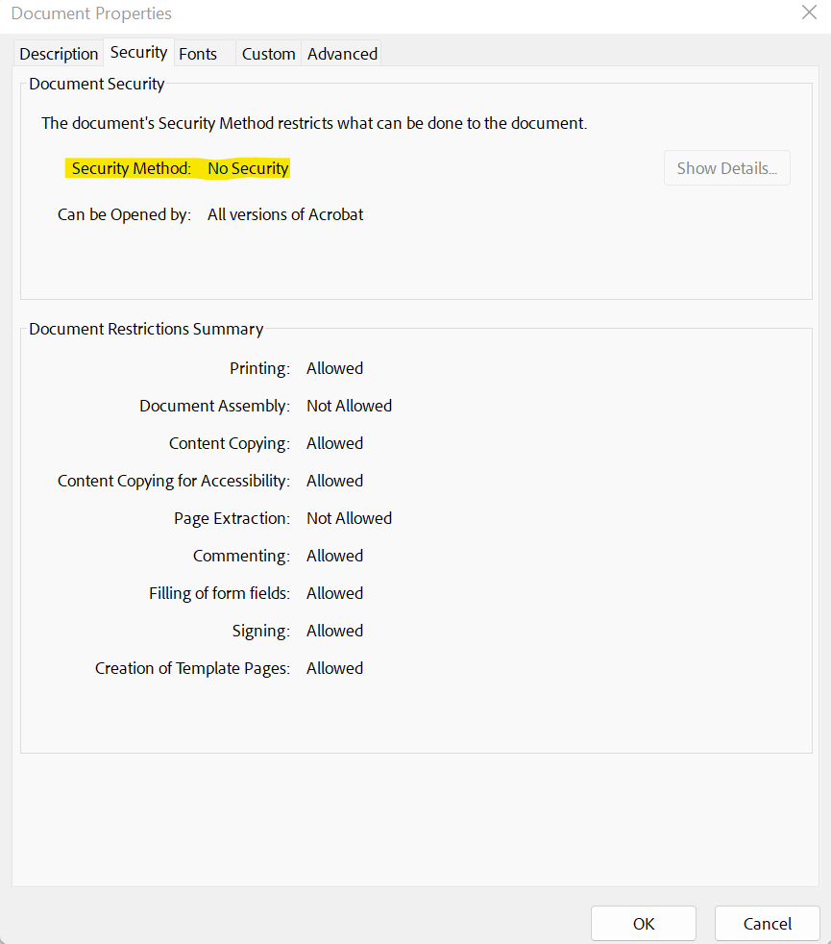

- Connect to worker Machine and check if there is any pop-up, if so, please cancel/close it.

